

NLP-BASED EMOTION DETECTION AND MENTAL HEALTH SUPPORT
PROJECT REPORT
Submitted to Bharathiar University in partial fulfillment of the requirements for the award of the degree of

Bachelor of Science in Computer Technology

Submitted by
C.N HARINI
(2326K0014)

Under the Supervision and Guidance of
Mr.S.DEEPANKUMAR M.C.A.,( Ph.D).,
Assistant Professor
Department of Computer Technology

MARCH 2026

CERTIFICATE

CERTIFICATE

This is to certify that the project entitled NLP-Based Emotion Detection and Mental Health Support submitted to Bharathiar University in partial fulfillment for the award of the degree of Bachelor of Science in Computer Technology is a record of original work done by C N Harini (2326K0014) during the period of study in KG College of Arts and Science under the supervision of Mr. S. Deepankumar, Assistant Professor, Department of Computer Technology.

Place: Coimbatore
Date:

Signature of the Guide Signature of the HoD

(College Seal)

Submitted for the Viva-Voce Examination held on

Internal Examiner External Examiner

DECLARATION

DECLARATION
I declare that the work which is being presented in this project report entitled NLP-Based Emotion Detection and Mental Health Support, submitted to the Department of Computer Technology, KG College of Arts and Science, Saravanampatti, Coimbatore for the award of the degree of Bachelor of Science in Computer Technology of the Bharathiar University, is an authentic record of my work carried out under the supervision and guidance of Mr.S.Deepankumar M.C.A.,( Ph.D). I have not plagiarized or submitted the same work for the award of any other degree.

March 2026
Coimbatore

________________________
(C.N Harini)

ACKNOWLEDGEMENT

ACKNOWLEDGEMENT
I express my sincere thanks to Dr.Ashok Bakthavathsalam, B.E., MS., Ph.D., Managing Trustee for allowing me to do this course of study and to undertake this project work.
It is my pleasure to express my sincere thanks to Dr. B. Vanitha, MA., M.Phil., Ph.D., Secretary, KG College of Arts and Science for her valuable thoughts.
I take this opportunity to convey my sincere thanks to Dr. S. Vidhya, MCA., M.Phil., Ph.D., NET., Principal, KG College of Arts and Science for her ethical encouragement at the duration of the course.
I take this opportunity to convey my sincere thanks to Dr.M.Usha, M.Sc., M.Phil., Ph.D., Dean – School of Computational Sciences, KG College of Arts and Science for her moral support throughout the course.
I have great pleasure in acknowledging my thanks to Dr. A. Lavanya , M.Sc., M.Phil., Ph.D., Head of the Department, Computer Technology, KG College of Arts and Science for her encouragement and help throughout the course.
I express my sincere thanks to Mr. S. Deepankumar, M.C.A.,(Ph.D)., Assistant Professor, Department of Computer Technology for his constant encouragement and motivation throughout the project. I thank for his endless support and encouragement towards the work.

- C N Harini

CONTENTS
CONTENTS
PARTICULARS | PAGENO
DECLARATION
CERTIFICATE
ACKNOWLEDGEMENT
CONTENTS
ABSTRACT
1.INTRODUCTION |  | 1
1.1 ABOUT THE PROJECT |  | 2
1.2 SYSTEM SPECIFICATION |  | 3
1.2.1 HARDWARE CONFIGURATION |  | 3
1.2.2 SOFTWARE SPECIFICATION |  | 3
2. SYSTEM STUDY |  | 4
2.1 EXISTING SYSTEM |  | 4
2.1.1 DRAWBACKS |  | 4
2.2 PROPOSED SYSTEM |  | 5
2.2.1 FEATURES |  | 5
3. SYSTEM DESIGN AND ENHANCEMENT |  | 6
3.1 FILE DESIGN |  | 6
3.2 INPUT DESIGN |  | 7
3.3 OUTPUT DESIGN |  | 8
3.4 DATABASE DESIGN |  | 9
3.5 CODE DESIGN |  | 10
3.6 SYSTEM MODULE |  | 11
3.6.1 MODULE DESCRIPTION |  | 12
3.7 REPORT |  | 13
4. TESTING AND IMPLEMENTATION |  | 14
4.1 TESTING METHODS |  | 14
4.1.1 SYSTEM IMPLEMENTATI |  | 20
4.1.2 SYSTEM ENHANCEMENT |  | 21
5. CONCLUSION |  | 22

FUTURE ENHANCEMENT | 23
BIBLIOGRAPHY | 24
APPENDICES | 25
- DATA FLOW DIAGRAM | 26
- TABLE DESIGN | 28
- SAMPLE CODING | 31
- SAMPLE INPUT | 33
- SAMPLE OUTPUT | 38

ABSTRACT
The NLP-Based Emotion Detection and Mental Health Support System is developed to provide accessible and immediate mental health assistance using advanced technologies such as Natural Language Processing (NLP), Sentiment Analysis, and Large Language Models (LLMs). Many individuals face difficulties accessing professional mental health support due to high costs, long waiting times, and social stigma. This system aims to address these challenges by offering an intelligent digital platform where users can express their emotions and receive supportive responses from an AI-based virtual psychologist.
The system analyzes user messages to detect emotions and understand their mental state. It uses a Dual-Layer Emotion Intelligence approach that combines lexicon-based emotion analysis with the contextual capabilities of the Groq AI engine. This combination helps accurately identify emotions such as stress, anxiety, sadness, or severe distress and provides appropriate responses and coping suggestions.
The platform also performs real-time risk assessment. If the system detects critical emotional conditions, it can generate alerts and support emergency intervention. Conversation history is stored to analyze emotional patterns and improve personalized responses.
The application is built using Python and Flask for the backend, SQLite for database management, and Groq API for intelligent language responses. The frontend is developed using HTML5, JavaScript, and Tailwind CSS, providing a responsive and user-friendly interface.

1.INTRODUCTION
Mental health challenges are increasing globally due to academic stress, work pressure, financial instability, and social isolation. Traditional mental healthcare systems often face limitations such as restricted operating hours, high consultation costs, social stigma, and long waiting periods. These barriers prevent many individuals from seeking timely psychological support. The NLP-Based Emotion Detection and Mental health support system is developed as a technological solution to address these limitations by offering a secure, automated, and continuously available mental health support platform.
The system leverages Artificial Intelligence technologies to analyze user conversations and detect emotional distress in real time. Using Natural Language Processing (NLP) and sentiment analysis, the platform evaluates textual inputs and assigns weighted emotion scores. These scores are processed through a risk assessment algorithm that determines the severity of the user’s emotional condition. This automated mechanism reduces the chances of human error and ensures consistent evaluation of distress signals.
A key feature of the system is its Real-Time Emergency Response Mechanism. When high-risk phrases or suicidal ideation markers are detected, the system automatically triggers an emergency alert. The alert is logged in the database and made accessible through the administrator dashboard. In cases where users grant location access, geographical data is stored securely to assist emergency responders if necessary.
The system serves two primary user groups: general users seeking emotional support and administrators responsible for monitoring critical cases. Users can register anonymously, ensuring privacy and encouraging open communication. Administrators can monitor risk distribution, review alerts, and manage response protocols efficiently.
By combining automation, intelligent risk detection, secure data management, and user-friendly design, the system represents a modern, scalable solution to improve accessibility, efficiency, and safety in mental healthcare support.

1.1ABOUT THE PROJECT
The NLP-Based Emotion Detection and Mental health support project is an advanced mental healthcare management system designed to provide intelligent, accessible, and secure emotional support using Artificial Intelligence technologies. The primary goal of this project is to bridge the gap between individuals experiencing psychological distress and the availability of timely professional assistance. By integrating Natural Language Processing (NLP), Sentiment Analysis, and Large Language Models (LLMs), the system delivers empathetic, context-aware responses while continuously monitoring emotional risk levels.
The platform introduces a Dual-Layer Emotion Intelligence System that combines a lexicon-based emotion scoring engine with advanced AI-driven contextual understanding. This hybrid approach ensures accurate detection of emotional states ranging from mild stress to critical crisis conditions. The system automatically calculates a real-time risk score for each user message and categorizes it into Low, Medium, High, or Critical levels. If the risk score exceeds a predefined threshold, an emergency alert is generated and stored in the database for administrative review.
NLP-Based Emotion Detection and Mental health support is structured into multiple integrated modules, including User Interface, Patient Registration, NLP & Emotion Analysis, Chat Management, Emergency Alert, and Data Management. The backend is developed using Python and Flask, while SQLite and SQLAlchemy handle secure database operations. The frontend is built using HTML, JavaScript, and Tailwind CSS to provide a responsive and psychologically safe interface.
Overall, the project demonstrates how AI-driven automation can enhance mental healthcare accessibility, reduce manual workload, ensure consistent risk assessment, and improve crisis intervention efficiency.

1.2 SYSTEM SPECIFICATIONS

1.2.1 HARDWARE CONFIGURATION

- Processor : Intel Core i5 or AMD Ryzen 5 (or higher)
- RAM : 8 GB minimum (16 GB recommended)
- Storage : 512 GB
- Network Interface : Gigabit Ethernet or High-Speed Wi-Fi Adapter
- Peripheral Devices : Standard Keyboard and Mouse Webcams and Microphones

1.2.2 SOFTWARE SPECIFICATIONS

- IDE : Visual Studio Code
- Frontend : HTML5 , CSS3 / Tailwind CSS , JavaScript
- Backend : Python , Groq SDK
- Database : SQLite
- Operating System : Windows 10/11 or Linux
- Browser : Google Chrome, Mozilla Firefox, or Microsoft Edge (latest versions).

2. SYSTEM STUDY

2.1 EXISTING SYSTEM
The traditional systems for managing mental health care and patient support rely heavily on manual or face-to-face methods. These include in-person therapy sessions, crisis hotlines managed by human operators, and physical paper records for patient history. While these systems provide high-quality care, they lack the scalability, immediate accessibility, and continuous availability needed for modern healthcare environments.
In the current system, patient verification and initial triage depend on scheduling appointments or waiting on hold for a hotline operator. These processes are prone to delays and can be deter individuals in acute distress. Futhermore, the reliance on handwritten notes or disconnected electronic health records (EHRs) often leads to fragmentation of information, making it difficult to track a patient’s emotional history over time or identify inconsistencies in their narrative.

2.1.1 DRAWBACKS

- Limited Availability: Traditional therapy is often restricted to business hours (9-5), leaving patients without support during nights and weekends when crises often occur.

- High Cost: Private therapy sessions are prohibitively expensive for many individuals, creating a socioeconomic barrier to mental healthcare.

- Stigma and Privacy: The requirement to physically visit a clinic or speak to a human can induce anxiety and fear of judgment, preventing many from seeking help.

- Delayed Intervention: Waiting lists for therapists can range from weeks to months, during which a patient’s condition may deteriorate significantly.

- Subjective Triage: Human assessment of risk can vary between practitioners; fatigue and burnout among hotline operators can lead to missed warning signs.

- Fragmented Data: Lack of a centralized, continuous log of the patient’s emotional state makes it hard to see patterns or triggers over time.

2.2 PROPOSED SYSTEM
The NLP-Based Emotion Detection and Mental Health Support system addresses the challenges of existing systems by introducing an integrated, automated, and secure platform. By combining modern AI technologies with user-centric design, the proposed system ensures accurate emotion tracking, immediate support, and seamless data management.
In this system, patient identification and interaction are achieved through secure digital sessions and NLP-based context recognition. This ensures a high level of accuracy and security. Conversations are digitized and stored in a centralized database (mental_health.db), allowing for real-time updates and easy access (by the AI). The system automates risk assessment and facilitates location-based emergency alerts, enhancing convenience and safety for patients and staff alike.

2.2.1 FEATURES
- Dual-Layer Emotion Detection: Combines a rule-based lexicon scorer for immediate keyword flagging with a Generative AI model for contextual nuance, ensuring reliable identification of distress.
- 24/7 Availability: The AI psychologist is always online, providing immediate responses to users regardless of the time or day.
- Real-time Risk Scoring: Automatically calculates a risk score (0-100) for every user message, updating the user’s status instantly.
- Emergency Alert System: Automatically triggers an alert record if the risk score exceeds a critical threshold (e.g., 70), capturing location data for potential intervention.
- Secure & Anonymous: Users can interact without revealing their full identity, encouraging honesty and reducing the fear of stigma.
- Integrated Platform: Facilitates seamless communication between the user interface, the analysis engine, and the database.
- Data Security: Protects sensitive patient information using secure session management and database isolation.
- User-friendly Interface: Simplifies navigation for users in distress, requiring no training to start a conversation.
- Analytics and Reporting: Provides structured data on emotional trends, helping to understand user needs better.

3. SYSTEM DESIGN AND ENHANCEMENT

3.1 FILE DESIGN
The NLP-Based Emotion Detection and Mental Health Support system is designed with a structured file management approach to ensure seamless data organization, storage, and retrieval. At its core, the project directory is divided into backend and frontend folders to separate concerns.

- Backend Directory: Contains the application logic.
  - main.py: The entry point of the Flask application, defining API routes and server configuration.
  - database.py: Defines the SQLAlchemy models (User, ChatHistory, EmergencyAlert) and the DatabaseManager class for abstraction.
  - nlp_engine.py: Contains the EmotionScorer class and the logic for calculating risk scores based on the lexicon.json.
  - groq_client.py: Manages the connection to the Groq API, handling prompt engineering and response retrieval.
  - lexicon.json: A structured data file containing keywords mapped to emotions and their severity weights.
  - mental_health.db: The SQLite database file storing persistent records.

- Frontend Directory: Contains the presentation layer.
  - index.html: The landing page with the “Get Started” call to action.
  - login.html / register.html: User authentication forms (simulated or functional).
  - chat.html: The main interface for the chat session.
  - dashboard.html: The admin view for monitoring alerts.
  - js/: Contains JavaScript files (chat.js, dashboard.js) that handle API calls and DOM manipulation.

This structured approach enhances maintainability, reducing code redundancy and improving overall efficiency in development and debugging. Configuration files like .env store API credentials and system parameters, ensuring security by keeping sensitive keys out of the codebase.

3.2 INPUT DESIGN

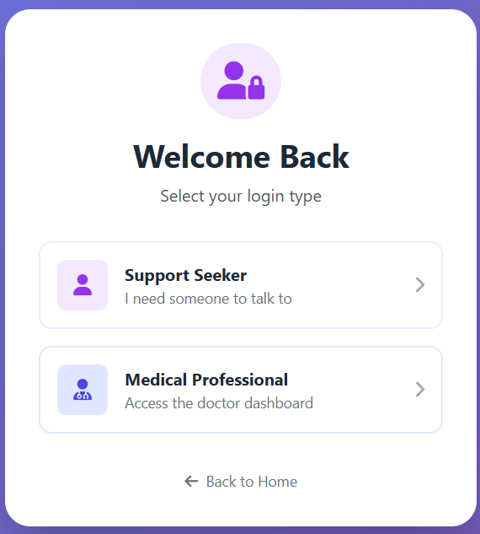

This screen shows the login selection page of the MindCare AI system. Users can choose to log in as a Support Seeker to get help or as a Medical Professional to access the doctor dashboard.

.

3.3 OUTPUT DESIGN

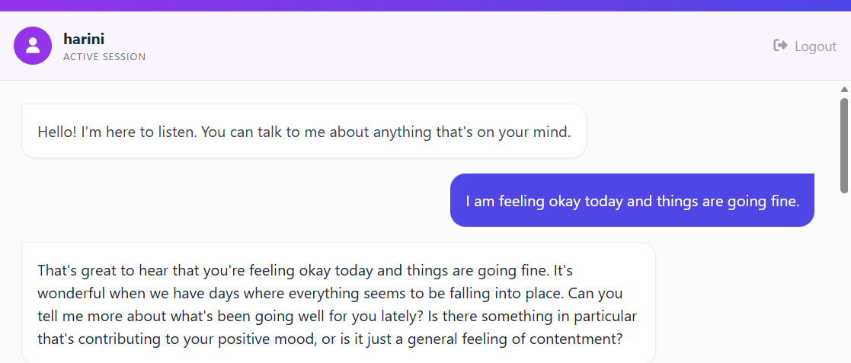

This output screen shows the real-time interaction between the user and the AI psychologist. The system analyzes the user’s message, determines a low-risk emotional state, and generates an empathetic response without triggering any emergency alert.

3.4 DATABASE DESIGN
The database structure of the system is designed for optimal performance and data integrity. The primary database, mental_health.db, is structured into multiple tables using SQLAlchemy’s declarative base.
- Normalization: The database is normalized to reduce redundancy. User details are stored once in the users table, while multiple chat messages are stored in chat_history linked by user_id.

- Indexing: Primary keys (UUIDs) are indexed for fast retrieval.

- Data Types: Efficient data types are chosen (e.g., Float for coordinates, Boolean for emergency flags, DateTime for timestamps).

The system employs data validation techniques, ensuring that every entry is cross-checked before being added to the database. These techniques prevent duplicate patient records and inconsistencies.

3.5 CODE DESIGN
index.html
Home Page
Get Started

Register.html
Registration Form
Name + Phone

Chat Interface
AI Psychologist
Risk Detection
Cchat.html

if Risk >= 50

Location Request
Emergency Alert

Admin.html
Admin Portal
View Alerts
Call Patient
See Location

The user starts on the home page, registers with their name and phone, and then chats with an AI psychologist. The system analyzes the conversation for risk, and if the risk level is high (≥50), it sends an alert with the user’s location to the admin portal for immediate action.

3.6 SYSTEM MODULES
The system modules phase involves designing, implementing, and integrating various components to ensure efficient and reliable patient identification and mental health tracking. The Tracker follows a modular development approach, ensuring scalability, maintainability, and security. Each module is designed to handle a specific function, allowing for seamless communication between different parts of the system.
MODULES
- User Interface
- Patient Registration
- NLP & Emotion Analysis
- Chat Management
- Emergency Alert

3.6.1 MODULE DESCRIPTION

USER INTERFACE MODULE
The User Interface Module is designed using HTML and Tailwind CSS to provide an interactive and responsive web interface for users. It allows smooth navigation between Home, Chat, and Resources sections. The module supports real-time chat display using a scrolling message container and applies custom CSS for a professional and calming user experience. Asynchronous JavaScript using the Fetch API ensures non-blocking communication with the backend server.
PATIENT REGISTRATION MODULE
The Patient Registration Module handles the collection and storage of patient information in a secure and anonymous manner. It uses SQLAlchemy to create and manage user records in the database. Unique patient identification is achieved through UUID generation, ensuring privacy. Input forms are provided to capture optional demographic information without mandating personal details.

NLP & EMOTION ANALYSIS MODULE
The NLP and Emotion Analysis Module identifies the emotional state of the user through text-based analysis. It uses the EmotionScorer class to compare user input with predefined emotional keywords stored in the lexicon.json file. Regular expressions are applied for text preprocessing, and weighted arithmetic calculations are used to compute emotion scores and overall mental health risk levels.
CHAT MANAGEMENT MODULE
The Chat Management Module controls user-system interactions and ensures meaningful conversations. It utilizes the GroqClient to generate intelligent and context-aware responses. The module maintains conversation continuity by storing chat history in a conversation store and logs all interactions into the chat_history database table for monitoring and analysis.
EMERGENCY ALERT
The Emergency Alert Module is responsible for detecting critical mental health conditions and triggering emergency notifications. It continuously monitors the calculated risk score after each interaction. When the risk score exceeds a predefined threshold, the module generates alert records in the emergency_alerts table and exposes them through an API endpoint for dashboard access.
DATA MANAGEMENT MODULE
The Data Management Module ensures efficient and secure handling of patient records and chat data. It uses SQLAlchemy sessions for database operations such as data retrieval and storage. Exception handling mechanisms are implemented to manage errors and ensure safe rollbacks. Patient data is secured through unique identifier-based authentication to maintain confidentiality and integrity.

3.7 REPORT
Mental health issues are becoming increasingly common due to stress, academic pressure, work-related challenges, and social factors. Many individuals hesitate to seek professional help because of stigma, lack of awareness, or limited access to mental health services. To address this issue, this project proposes an NLP-Based Emotion Detection and Mental Health Support System that provides timely emotional assistance using Artificial Intelligence techniques.
The proposed system uses Natural Language Processing (NLP) to analyze user text inputs and identify emotional states such as happiness, sadness, anger, anxiety, and suicidal tendencies. Users can freely express their feelings through text, and the system processes this input to detect emotions and assess the severity of mental distress. Based on the detected emotions, the system categorizes the user’s condition into different risk levels such as low, medium, high, or critical.
Once the risk level is identified, the system generates empathetic and supportive responses to help the user cope with their emotional state. In critical situations, where suicidal or self-harm intent is detected, the system automatically triggers an emergency alert mechanism to notify administrators or support personnel for immediate action. All user interactions and emotion analysis results are securely stored in the database for monitoring and future reference.
The system is designed using a modular architecture that includes an emotion detection module, risk assessment module, response generation module, database module, and alert module. Testing techniques such as unit testing, integration testing, system testing, user acceptance testing, and performance testing are conducted to ensure accuracy, reliability, and efficiency of the system.
Overall, the NLP-Based Emotion Detection and Mental Health Support System provides an accessible, confidential, and real-time solution for mental health assistance. While it does not replace professional therapy, it serves as an effective support tool for early detection of emotional distress and timely intervention.

4. TESTING AND IMPLEMENTATION
Testing and implementation play a crucial role in ensuring the systems functions efficiently and securely. This phase involves evaluating system performance, verifying accuracy, and integrating the software within a real-world healthcare setting context. The testing strategy follows a structured approach, including unit testing, integration testing, and user acceptance testing to ensure the system meets functional and non-functional requirements.
4.1 TESTING METHODS
- Unit Testing
- Integeration Testing
- System Testing
- User Acceptance Testing (UAT)
- Performance Testing

UNIT TESTING
Unit testing is performed to verify the correct functioning of individual system components. Modules such as emotion scoring, API endpoints, and database operations are tested separately. Test cases include checking EmotionScorer accuracy with phrases like “I want to die,” validating proper JSON responses from Flask routes, and ensuring user data is correctly stored and retrieved from the database.

TABLE 4.1: UNIT TESTING

Test Case ID | Module | Test Description | Input | Expected Output | Actual Output | Status
UT01 | EmotionScorer | Detect sadness keywords | “I feel very sad and lonely” | Sadness score > 0, Medium risk | As expected | Pass
UT02 | EmotionScorer | Detect suicidal intent | “I want to die” | Risk score > 70, Emergency = True | As expected | Pass
UT03 | Chat API | Validate empty message | "" (empty string) | Error message returned | As expected | Pass
UT04 | Database | Store chat history | Valid message | Record saved in chat_history table | As expected | Pass
UT05 | Alert Module | Generate emergency alert | Risk score = 85 | Entry created in emergency_alerts | As expected | Pass

INTEGRATION TESTING
Integration testing ensures that different modules work correctly when combined. It verifies the interaction between main.py, nlp_engine.py, and groq_client.py, ensuring smooth data flow. Tests include checking that a user message triggers the NLP engine, saves data to the database, and returns an AI response, confirming emergency alerts are created for high-risk scores, and verifying that the frontend chat window correctly displays messages from the backend.
TABLE 4.2: INTEGRATION TESTING

Test Case ID | Modules Involved | Test Description | Input | Expected Result | Status
IT01 | UI → Backend → NLP | User sends emotional message | “I feel hopeless” | NLP processes text and returns response | Pass
IT02 | NLP → Database | Emotion score storage | Emotional text | Emotion & risk score saved | Pass
IT03 | NLP → Alert → DB | High-risk detection flow | “I want to kill myself” | Alert generated & stored | Pass
IT04 | Backend → UI | AI response rendering | Normal user text | AI reply shown in chat UI | Pass
IT05 | Backend → Dashboard | Alert visibility | Emergency triggered | Alert visible in admin dashboard | Pass

SYSTEM TESTING
System testing verifies that the entire system works correctly as a whole. It checks the integration of the user interface, NLP emotion analysis, AI response generation, database storage, and emergency alert system. The test ensures accurate risk detection and proper alert triggering.
TABLE 4.3: SYSTEM TESTING

Test Case ID | Feature | Test Scenario | Expected Outcome | Status
ST01 | User Registration | Register new user | User ID generated successfully | Pass
ST02 | Chat Functionality | Continuous conversation | Context maintained | Pass
ST03 | Risk Classification | Different emotions | Correct risk category shown | Pass
ST04 | Location Capture | User allows location | Latitude & longitude stored | Pass
ST05 | Emergency Handling | Critical emotion detected | Emergency alert triggered | Pass

USER ACCEPTANCE TESTING
User Acceptance Testing ensures that the system is easy to use and meets user expectations. Users can interact anonymously, receive empathetic AI responses, and administrators can view emergency alerts clearly. The system was accepted as user-friendly and effective.
TABLE 4.4: USER ACCEPTANCE TESTING

Test Case ID | User Type | Scenario | Expected Result | Status
UAT01 | General User | Chat anonymously | No personal data required | Pass
UAT02 | Distressed User | Express suicidal thoughts | Immediate supportive response | Pass
UAT03 | Admin | View emergency alerts | Alerts listed clearly | Pass
UAT04 | Admin | Resolve alert | Status updated to “Resolved” | Pass
UAT05 | Mobile User | Use system on phone | Responsive UI works | Pass

PERFORMANCE TESTING
Performance testing evaluates the speed, responsiveness, and stability of the system. It provides real-time responses, handles multiple users efficiently, and triggers alerts without delay, ensuring reliable performance.
TABLE 4.5: PERFORMANCE TESTING

Test Case ID | Parameter | Expected Value | Observed Result | Status
PT01 | API Response Time | < 3 seconds | ~1.5 seconds | Pass
PT02 | Concurrent Users | 20+ users | No crash | Pass
PT03 | Database Write | Real-time logging | Successful | Pass

4.1.1 SYSTEM IMPLEMENTATION
1.Deployment Environment
The NLP-Based Emotion Detection and Mental Health Support system is designed for deployment on local servers or cloud-based platforms (like AWS, Heroku, or Render), ensuring real-time accessibility and secure data management. The implementation phase includes the following key steps:
- Configuring database storage: The system establishes a structured SQLite database to store patient records and history. The data file is secured with file-system permissions.
- Setting up API integrations: The system integrates Groq API keys into the environment variables (.env) to enable AI functionality.
- Environment Setup: Installing dependencies via requirements.txt (Flask, SQLAlchemy, etc.) in a virtual environment.
The deployment environment is tested rigorously to ensure scalability, security, and seamless interaction between different modules.
2. Training and Documentation
To ensure smooth adoption of the system, comprehensive training sessions (simulated via this documentation) are provided for system administrators. These sessions focus on essential functionalities, including:
- Dashboard Monitoring: A walkthrough on how to view and manage emergency alerts.
- System Maintenance: Guidance on backing up the mental_health.db file.
- Privacy Protocols: Training on how to handle sensitive user data ethically.

4.1.2 SYSTEM ENHANCEMENT
The NLP-Based Emotion Detection and Mental Health Support System can be enhanced further to improve its accuracy, scalability, and overall user experience. The current system mainly focuses on text-based emotion detection using Natural Language Processing techniques. As a major enhancement, voice-based emotion detection can be incorporated. By analyzing speech features such as tone, pitch, speed, and pauses, the system can identify emotions more precisely, especially in cases where users find it difficult to express feelings through text alone.
Another important enhancement is the integration of multilingual support. By allowing users to interact in multiple languages, the system can become accessible to a broader population across different regions and cultures. This enhancement will significantly increase usability and adoption of the system in real-world environments.
The system can also be improved by incorporating advanced machine learning and deep learning models, such as transformer-based language models and emotion classification networks. These models can learn from large datasets and continuously improve emotion detection accuracy and risk prediction over time. This will reduce false predictions and enhance the reliability of the system.
Additionally, the system can be enhanced by integrating real-time professional mental health support, such as live chat or call connectivity with counselors and emergency helplines during critical situations. This ensures immediate human intervention when required. The development of mobile and web-based applications will further improve accessibility, allowing users to seek support anytime and anywhere.
With these enhancements, the system can evolve into a more intelligent, adaptive, and comprehensive mental health support platform capable of addressing complex emotional needs eff

5. CONCLUSION
The NLP-Based Emotion Detection and Mental Health Support system has successfully demonstrated its potential to enhance efficiency, security, and accuracy in mental health support and crisis intervention. By integrating AI-driven emotion recognition and real-time conversation analysis, the system ensures that patients receive immediate attention and that high-risk cases are identified instantly. This automated approach significantly reduces the barrier to entry for therapy, prevents unauthorized access to sensitive records, and streamlines the entire mental health triage process. The combination of automation and digital record-keeping significantly enhances patient safety by minimizing human error and ensuring that the right intervention reaches the right individual at the right time.
One of the key strengths of the system is its ability to automate key processes, such as risk scoring and alert generation, thereby reducing the workload on human crisis responders. Traditional manual methods often lead to inefficiencies, mismanagement, and missed warning signs. By implementing this technology, healthcare providers can focus more on delivering clinical care rather than being burdened with administrative tasks. Furthermore, the system’s user-friendly interface, powered by Tailwind and Flask, ensures a seamless experience for both healthcare providers and patients.
The modular and scalable architecture of the system makes it highly adaptable for future advancements. Features such as cloud-based data storage, voice-to-text integration, and AI-driven predictive analytics for long-term mental health monitoring can be integrated into future versions to further enhance its capabilities. Moreover, additional security measures such as end-to-end encryption and multi-factor authentication can ensure compliance with healthcare regulations while safeguarding sensitive medical information.

FUTURE ENHANCEMENT
The NLP-Based Emotion Detection and Mental Health Support System can be extended in the future to provide more advanced, accurate, and comprehensive mental health support. One of the major future enhancements is the integration of voice-based emotion detection. By analyzing speech features such as tone, pitch, and speaking rate, the system can identify emotions more effectively, especially for users who are unable to express their feelings clearly through text.
Another important enhancement is the implementation of face recognition and facial emotion detection. By analyzing facial expressions through a camera, the system can identify emotions such as happiness, sadness, anger, or stress in real time. This feature will allow the system to understand the user’s emotional state more accurately and provide better support, especially when verbal or textual communication is limited.
Another significant enhancement is the implementation of multilingual support, which will allow users to interact with the system in different regional and international languages. This will increase accessibility and ensure inclusivity for users from diverse linguistic backgrounds.The system can also be improved by incorporating advanced machine learning and deep learning models, such as transformer-based language models, to enhance emotion classification accuracy and reduce false predictions.In future versions, the system can be integrated with professional mental health services, including live chat or appointment scheduling with certified counselors and psychologists. During critical situations, automatic integration with emergency helplines and crisis intervention services can ensure immediate human support.
Additionally, the development of mobile and web-based applications will make the system easily accessible anytime and anywhere. Features such as emotion trend analysis, personalized mental health recommendations, and secure cloud-based data storage can further enhance the effectiveness of the system.With these future enhancements, the system can evolve into a scalable, intelligent, and reliable mental health support platform capable of addressing complex emotional and psychological needs.

BIBLIOGRAPHY
REFERED BOOKS
[1] Jurafsky, D., & Martin, J. H. (2024). Speech and Language Processing. Pearson. (Deep Learning and NLP foundations).
[2] Picard, R. W. (2000). Affective Computing. MIT Press. (Emotion recognition in computers).
[3] Russell, S., & Norvig, P. (2021). Artificial Intelligence: A Modern Approach. Pearson.
[4] Goleman, D. (1995). Emotional Intelligence. Bantam Books. (Psychological framework for emotion).
REFERED WEBSITES
[1] Flask Documentation - https://flask.palletsprojects.com/
[2] SQLAlchemy Documentation - https://www.sqlalchemy.org/
[3] Tailwind CSS Documentation - https://tailwindcss.com/
[4] National Institute of Mental Health (NIMH) - Technology and the Future of Mental Health Treatment - https://www.nimh.nih.gov/
[5] Groq API Reference - https://console.groq.com/docs/

APPENDICES
A. DATA FLOW DIAGRAM
A Data Flow Diagram (DFD) is a diagram that describes the flow of data and the processes that change data throughout a system. It’s a structured analysis and design tool that can be used for flowcharting in place of or in association with information. Oriented and process oriented system flowcharts. Four basic symbols are used to construct data flow diagrams. They are symbols that represent data source, data flows, and data transformations and data storage. The points at which data are transformed are represented by enclosed figures, usually circles, which are called nodes.

Data Flow Diagram Symbols


- Destination of the data

  - Shows Data Flow


  - Represent a process

  - Shows data source

LEVEL 0
Chat Message/ Location
Admin / Emergency Responder
Chat Message
AI Response / Risk Level
Chatbot
User
(patient)

LEVEL 1

Prompt + Content
Read Keywords
Emotion Scores
User Message
Store User Data
Registration Details
Lexicon.json
NLP & Emotion Analysis
Chat Processing
Response Generation
Emergency Alerts
Lexicon.json
User
Users
User Registration
Users
Emergency Alerts
Risk Assessment

B. TABLE DESIGN

TABLE NAME: USERS
PRIMARY KEY: ID

Field Name | Data Type | Description | Constraints
id | VARCHAR(36) | Unique identifier for patient (UUID) | PRIMARY KEY, NOT NULL
name | VARCHAR(100) | Full name of the patient (Optional) | NOT NULL
phone | VARCHAR(20) | Contact phone number | NOT NULL
location | VARCHAR(200) | Human-readable address/location | NOT NULL
latitude | FLOAT | GPS Latitude | NOT NULL
longitude | FLOAT | GPS Longitude | NOT NULL
created_at | DATETIME | Timestamp of registration | DEFAULT CURRENT_TIMESTAMP

TABLE NAME: CHAT_HISTORY
PRIMARY KEY: id
FOREIGN KEY: user_id

Field Name | Data Type | Description | Constraints
id | VARCHAR(36) | Unique identifier for the message | PRIMARY KEY, NOT NULL
user_id | VARCHAR(36) | Link to the users table | FOREIGN KEY
message | TEXT | The content of the user’s message | NOT NULL
emotion_scores | JSON | Serialized dictionary of emotion scores | NOT NULL
risk_score | FLOAT | Calculated risk level (0-100) | NOT NULL
is_emergency | BOOLEAN | Flag for high-risk messages | DEFAULT FALSE
created_at | DATETIME | Timestamp of the message | DEFAULT CURRENT_TIMESTAMP

TABLE NAME: EMERGENCY_ALERTS
PRIMARY KEY: id
FOREIGN KEY: user_id

Field Name | Data Type | Description | Constraints
id | VARCHAR(36) | Unique identifier for the alert | PRIMARY KEY, NOT NULL
user_id | VARCHAR(36) | Link to the users table | FOREIGN KEY (users.id)
risk_score | FLOAT | The score that triggered the alert | NOT NULL
status | VARCHAR(20) | Status of the alert (active, resolved) | DEFAULT ‘active’
created_at | DATETIME | Timestamp of the alert | DEFAULT CURRENT_TIMESTAMP

C. SAMPLE CODING

Emotion Detection using NLP

def calculate_emotion_scores(self, text: str) -> Dict[str, float]:
processed_text = self.preprocess_text(text)
words = processed_text.split()
scores = {}

for emotion, data in self.lexicon.items():
keywords = data['keywords']
weight = data['weight']
matches = 0

for keyword in keywords:
if keyword in processed_text:
matches += 1

raw_score = matches * weight * 10
scores[emotion] = min(raw_score, 100)

return scores

Weighted Risk Calculation

def calculate_risk_score(self, emotion_scores):
critical = ['suicidal', 'self_harm', 'hopelessness']
critical_max = max([emotion_scores.get(c, 0) for c in critical])

if critical_max >= 80:
return critical_max

final_score = critical_max * 0.7
return min(final_score, 100)

Risk Level Classification

def get_risk_level(self, risk_score):
if risk_score >= 70:
return "Critical"
elif risk_score >= 50:
return "High"
elif risk_score >= 30:
return "Medium"
else:
return "Low"

D. SAMPLE INPUT
LANDINGPAGE

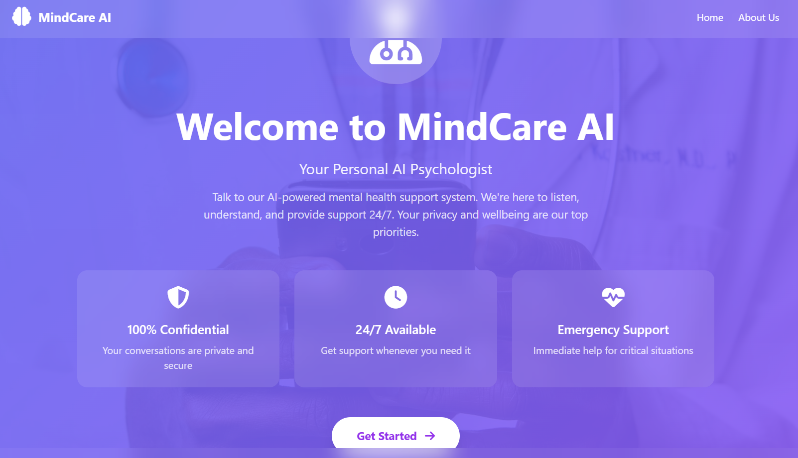

This screen displays the home page of the MindCare AI system, welcoming users to the platform. It highlights features such as confidential conversations, 24/7 support, and emergency mental health assistance.

USER / DOCTOR LOGIN



This screen shows the login selection page of the MindCare AI system. Users can choose to log in as a Support Seeker to get help or as a Medical Professional to access the doctor dashboard.

USER REGISTRATION

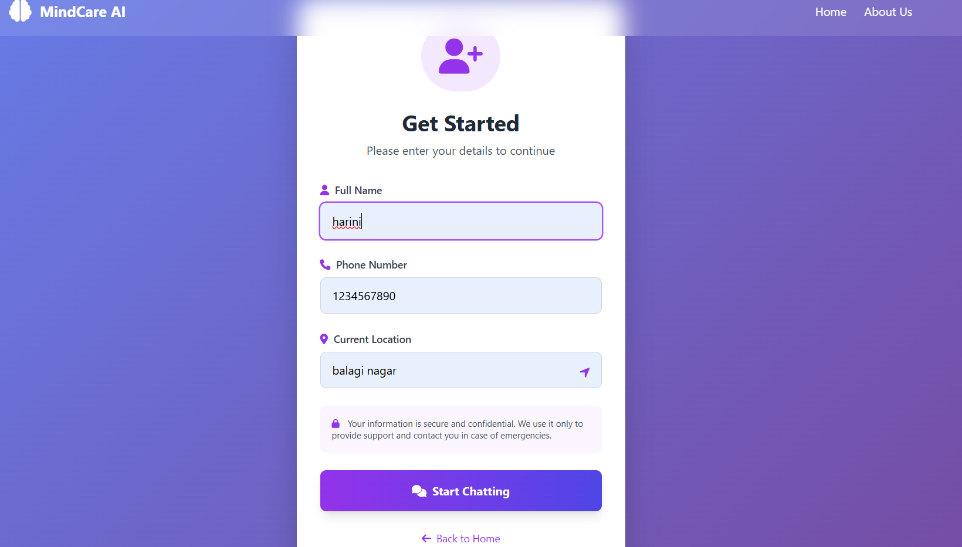

This screen allows users to enter personal details such as name, phone number, and location to begin using the MindCare AI system. After filling the details, users can click “Start Chatting” to start the support conversation.

ADMIN LOGIN

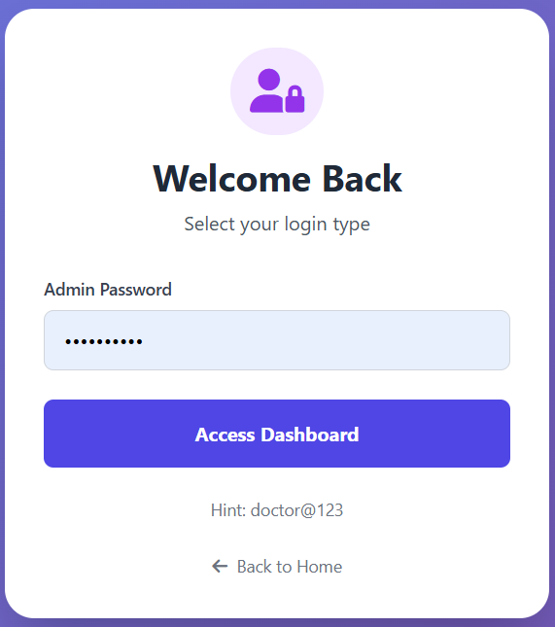

This screen is used by medical professionals to access the dashboard by entering the admin password. After authentication, they can view and manage user support information.

LOW RISK
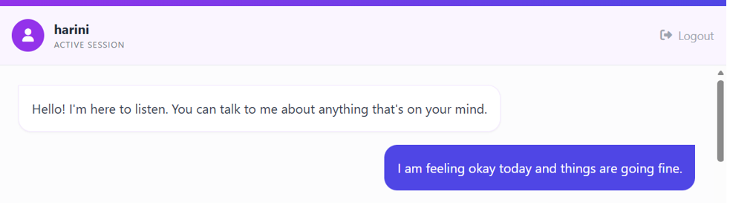

MEDIUM RISK

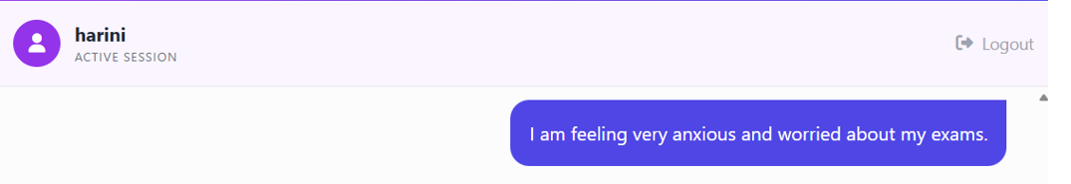

CRITICAL RISK

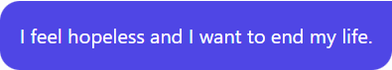

E. SAMPLE OUTPUT

LOW RISK



This output screen shows the real-time interaction between the user and the AI psychologist. The system analyzes the user’s message, determines a low-risk emotional state, and generates an empathetic response without triggering any emergency alert.

MEDIUM RISK

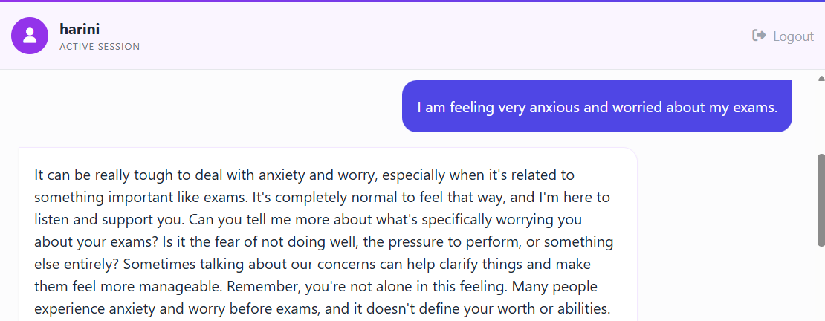

This output shows the system detecting anxiety-related keywords in the user’s message. The NLP module assigns a moderate risk score, and the AI generates an empathetic response without triggering an emergency alert.

CRITICAL RISK

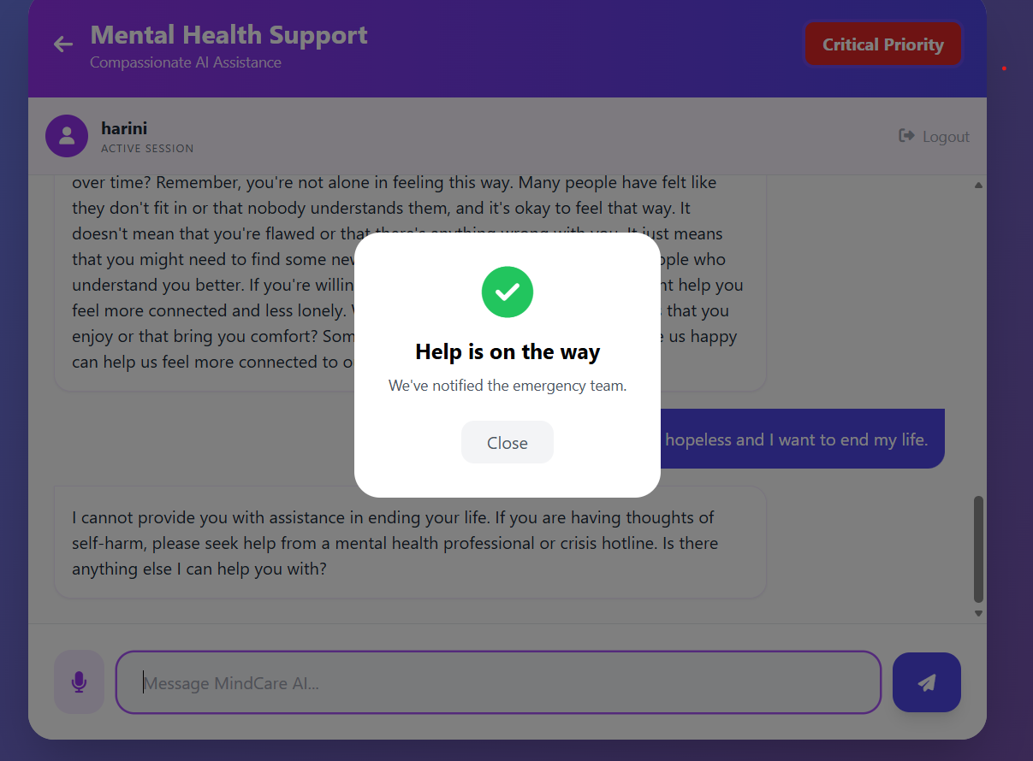

This screen shows the mental health chat interface where the AI detects a high-risk message from the user.An alert popup confirms that emergency support has been notified to assist the user immediately.

DOCTOR DASHBOARD
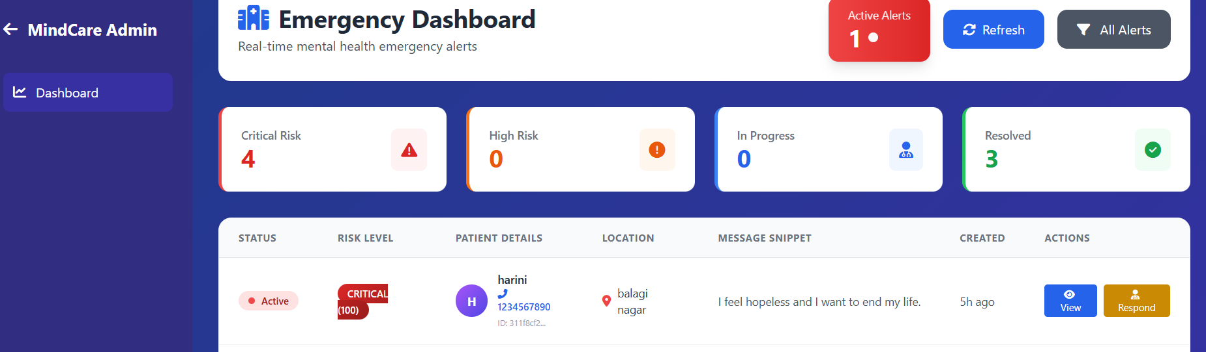

This screen displays the Admin Emergency Dashboard, which shows real-time mental health alerts and risk levels.Administrators can monitor critical cases, view patient details, and respond to emergency situations quickly.

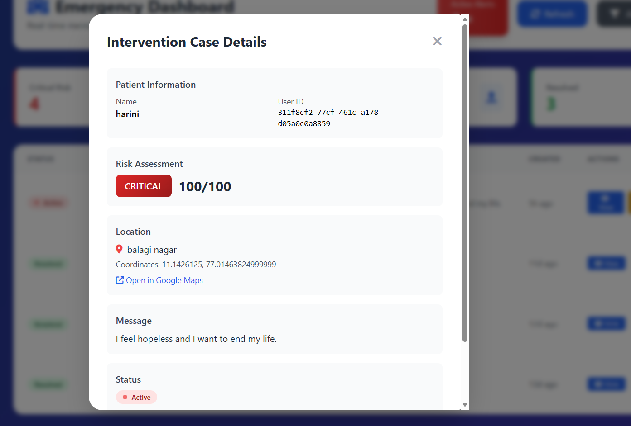

This screen shows the Intervention Case Details, providing detailed information about a patient in a critical mental health situation. It displays the risk level, patient details, location, and message, helping professionals take immediate action..

